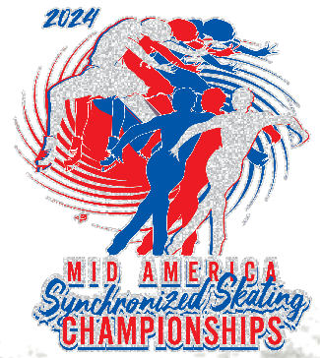

2024 Mid America Accommodations

Restaurants Convenience Stores

Juan Blancos Tacos and Tequila
34275 Utica Road
Fraser, MI 48026
(586) 872-2637
juanblancos.com)
(Located across from the Rink)

Big Boy Restaurant

34500 Utica Rd
Fraser, MI 48026
home (bigboy.com)
(Located in Rink Parking Lot)

Meijer
34835 Utica Rd.
Fraser, MI 48026
(586) 415-6400
www.meijer.com

Walgreens
15267 E 14 Mile Rd,
Fraser, MI 48026

www.walgreens.com

Vendors and Concessions in the Rink
• Vendors will be located throughout the upper concourse of the competition rink. Please take
the time to visit and see what offerings are available.
• Big Boy Arena concession stands, and Slap Shotz Bar will be open

